Name: Guness Chandradev

Cohort: DGD 1

Module name: Introduction to Game AI

Pruning Algorithm

The algorithm uses a minimax function to explore all the possible moves to find the best one.

Here is the minimax part of the script:

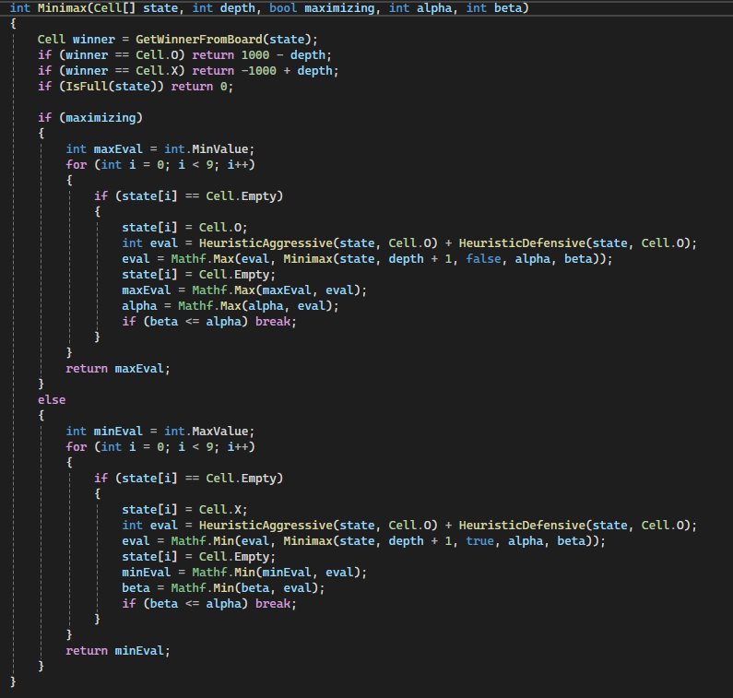

Heuristic algorithms

1. Offensive heuristic

With this algorithm, the AI get points for being close to winning. For example, if the AI is one move away from winning, it scores +100 points, and if it is already has 3 marks in a row, it has won the game and scores +1000 points.

Here is the offensive heuristic part of the script:

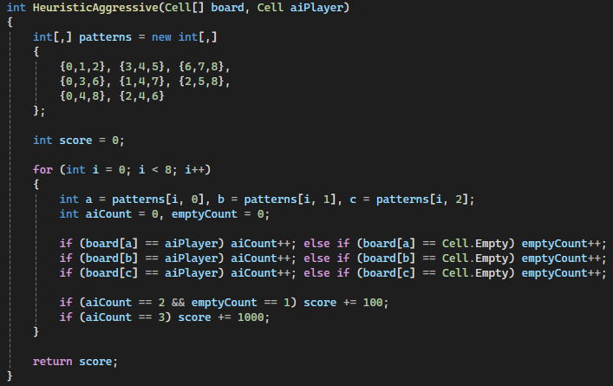

1. Defensive heuristic

With this algorithm, the AI loses point whenever it gets into a dangerous situation. For example if there are 2 X’s and 1 empty space would mean the player might win thus the AI loses 50 points, and if the player has already won the AI would lose 1000 points.

Here is the defensive heuristic part of the script:

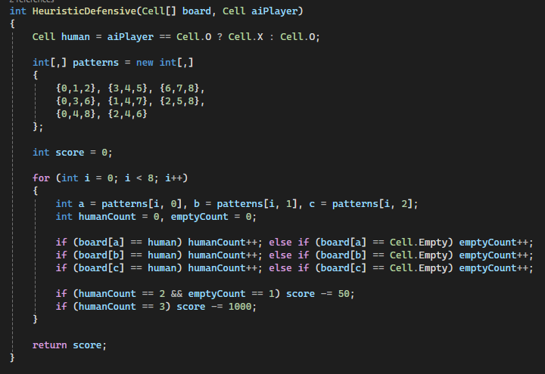

Rule - Based Algorithm

This algorithm serve as the rule for the game. The rule being that if there is the same symbol in three space in a row. It is considered a win for either the player(X) or the AI(O) depending on the symbol.

Here is the rule-based part of the script:

